Dear Vendor: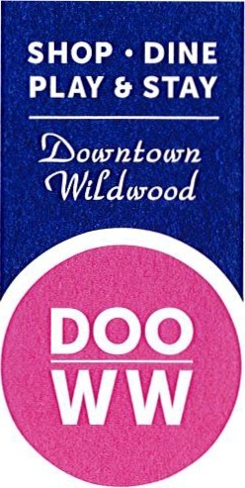

January 5, 2015

Wildwood Business Improvement District Management Corporation

wildwoodbusinessdistrict@gmail.com

PO BOX 2635
Wildwood, NJ 08260
The Wildwood Business Improvement District (WBID) is accepting vendor applications for the 2015 Downtown Wildwood Farmers Market! The first season was a huge success as confirmed by the Atlantic City Press' 8/31/14 headline "1st Farm Market A Winner"! Vendors and shoppers praised the market, which won the "Best New Attraction" award from the Wildwood Chamber of Commerce and "Best of Free Time" award from Catamaran Media!

www.DOOWW.com The Grand Opening of the 2015 Farmers Market will take place Memorial
Day Weekend on Saturday, May 23rd.. Located on the corner of Pacific
and Schellenger Avenues, the Downtown Wildwood Farmers Market will be held from 8 am until12:30 pm, for 16 weeks, through September 5th.

We are starting the market on Memorial Day weekend and adding 6 weeks in 2015! The season rate of
$400 for a single booth equates to $25 per week an d is quite a bargain! Vendor space at the Downtown
Wildwood Farmers Market is limited and will be in great demand. Please submit your application early.

The Wildwood Business Improvement District, in partnership with the GWTIDA and the City of Wildwood, will once again support the Downtown Wildwood Farmers Market with a complete package of marketing and advertising that will include print, radio, banner plan es, signs and social media.

Applications to sell at the Downtown Wildwood Farmers Market are being accepted from Farmers, Bakers, Restaurants, Specialty Food Suppliers, Wineries & Breweries. The weekly market will also include Family Entertainment and Children's Activities.

Vendors must commit to attending the Farmers Market from Memorial Day Weekend to Labor Day Weekend. Complete vendor applications with 25% deposit are due by March 20, 2015. Applications will be reviewed upon receipt and wait lists will be maintained as categories are filled. All applicants will be advised of their status by April 3, 2015. Any applicants who are denied or'wait listed will receive a full refund. Full season-fees must be paid by May 1st to reserve a space on the market vendor map.

Please review the 2015 D owntown Wildwood Farmers Market Rules and Regulations prior to submitting your application.

Thank you for your interest in the Downtown Wildwood Farmers Market! We look forward to working wi th you and celebrating another successful season!

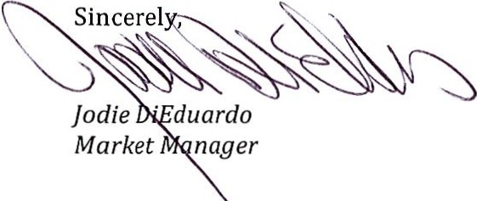

WBID Farmers Market Committee, P.O. Box 2635, Wildwood, NJ 08260 (609} 523-1602 wildwoodbusinessdistrict@gmail.com

